Practical 3
Controlling an Led with Python Program & Node Red

Steps: -
- Take out the Mouse, Keyboard and Monitor wires from the CPU
- And then connect those to the Raspberry Pi
- Insert the Memory card keeping the yellow lines circuit downside
- Connect the Charger to the plug and to the raspberry pi
- Take the bread board and the 330 ohm resistor (color sequence – Orange – Red- Brown - Golden)
- Take Jumper Wires
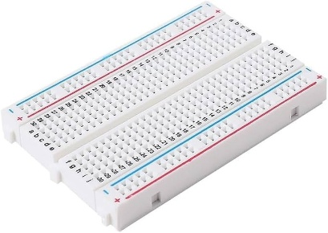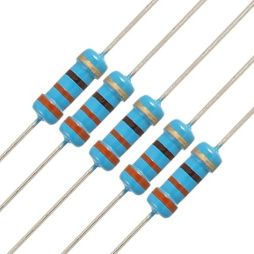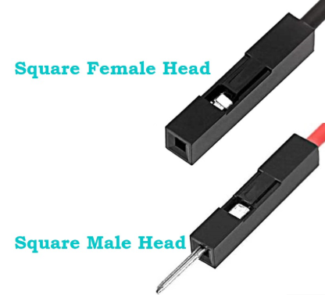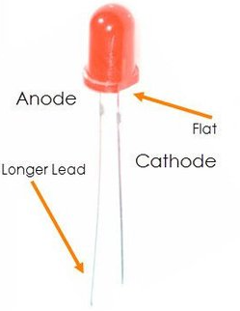
Bread Board 330 Ohms Resistor Jumper Wires LED

40 GPIO Pins / Headers
Upper – Even pins
Lower – Odd pins
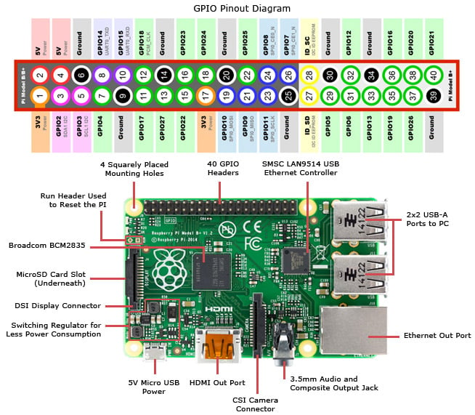
- In the Other PC Open the VNC Viewer then connect to the Raspberry Pi PC. (If not connected then in Raspberry Pi PC in terminal type the command ifconfig
- In the raspberry pi - physical pin 15 and for ground pin 6, connect the female side pin to the raspberry pi GPIO Headers as given
- Now on the Bread Board the 15 no. pin put that on the red line (right side outer section) and
- the 6 no. pin on the Blue line (left side inner section)
- Now aside to the 15 pin put the resistor’s one end and the other end in the right side inner section of the bread board
- Then the LED’s Long leg put aside (baju me)the resistor and the other short leg on the other side of the divider of the bread board
- The 6 pin put it aside the other side of the divider aside to the short leg of LED
- Hindi Explanation Below -
15 no. pin pe jumper wire (white wire) – woh connect hoga outer part of right side
White wire ke baju me resistor ka ek pin and uska dusra end jayega right side ke inner part me
Resistor ka dusra part ke niche LED ka longer leg – and shorter leg on inner part of left side
6 no. pin pe jumper wire (red wire) – woh connect hoga LED ke shorter leg ke niche
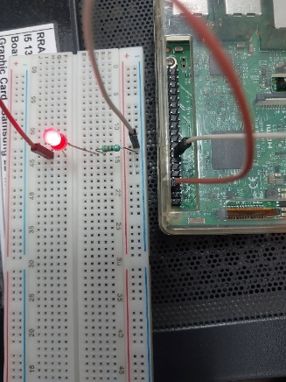
- In the Raspberry Pi PC, Go to the Raspberry Pi icon > Programming > Thonny Python IDE
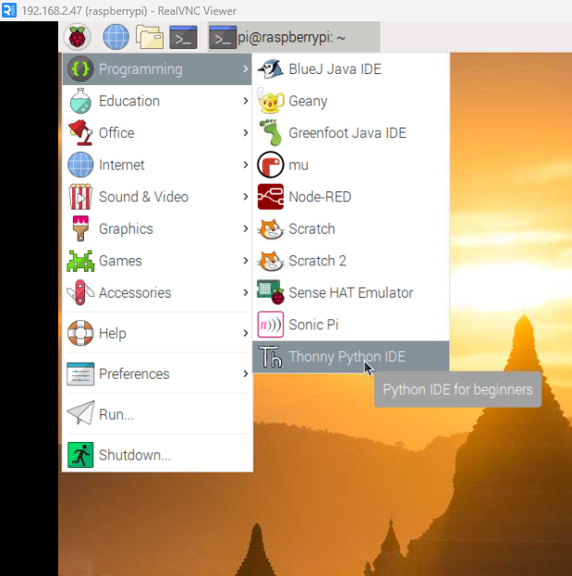
- Write the Program for the LED.
# Blinking LED Program
# Connect the LED to GPIO22 (i.e. Physical Pin 15)

import RPi.GPIO as GPIO
from time import sleep

# Set the pin numbering mode
GPIO.setmode(GPIO.BCM) #Or use this GPIO.setmode(GPIO.BOARD)

# Define LED pin (GPIO22 = Physical Pin 15)
ledPin = 22 #ledPin = 15

# Set up the LED pin as output
GPIO.setup(ledPin, GPIO.OUT)
GPIO.output(ledPin, False)

try:
while True:
GPIO.output(ledPin, True) # LED ON
sleep(1) # wait for 1 second
GPIO.output(ledPin, False) # LED OFF
sleep(1) # wait for 1 second

finally:
GPIO.output(ledPin, False)
GPIO.cleanup() # reset the GPIO pins

PART B
- In Raspberry Pi PC, Click on Raspberry Pi icon then in > Programming > Node Red > open and Copy the below link from there
http://192.168.2.47:1880
- Paste that in the Internet Explorer, Node RED Application will start.
- Drag the 2 Inject from Input from the Left Panel and Drag rpi gpio out from the Raspberry Pi.
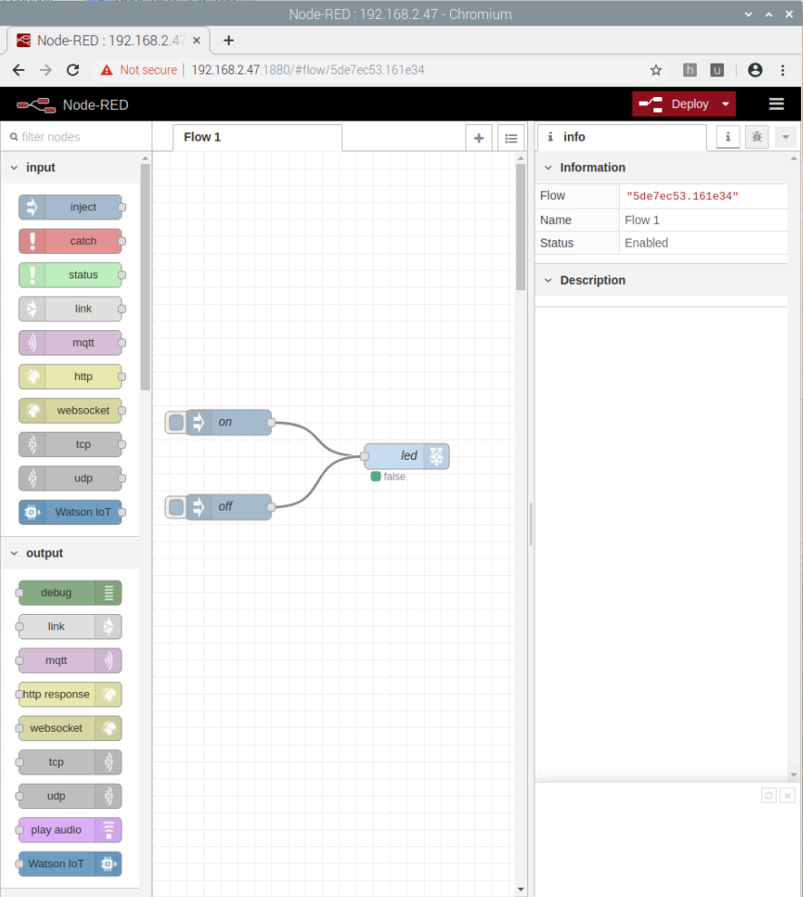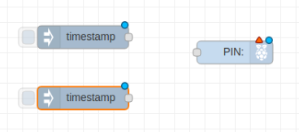
- Double click on the node and then in Payload select True and name as it on then click on done.
- Then for the other node (below one node) double click and then in Payload select False and name it as off then click on done.
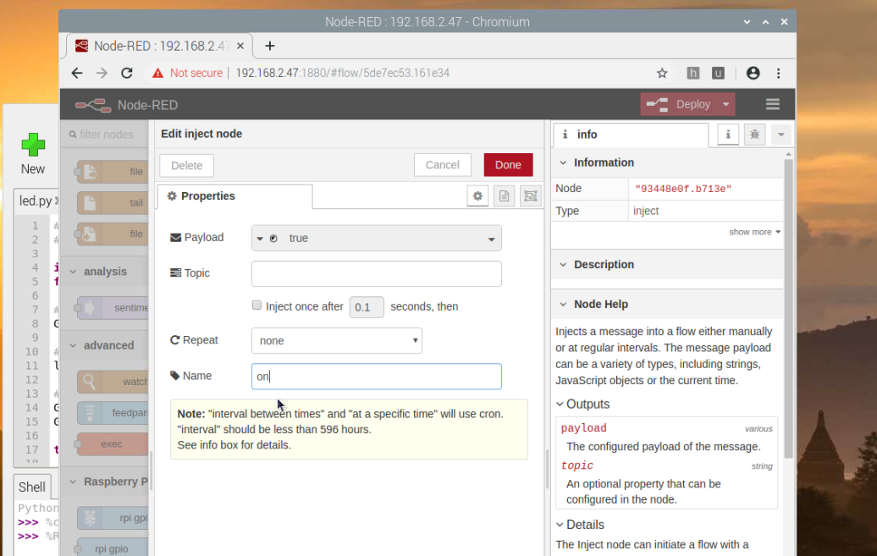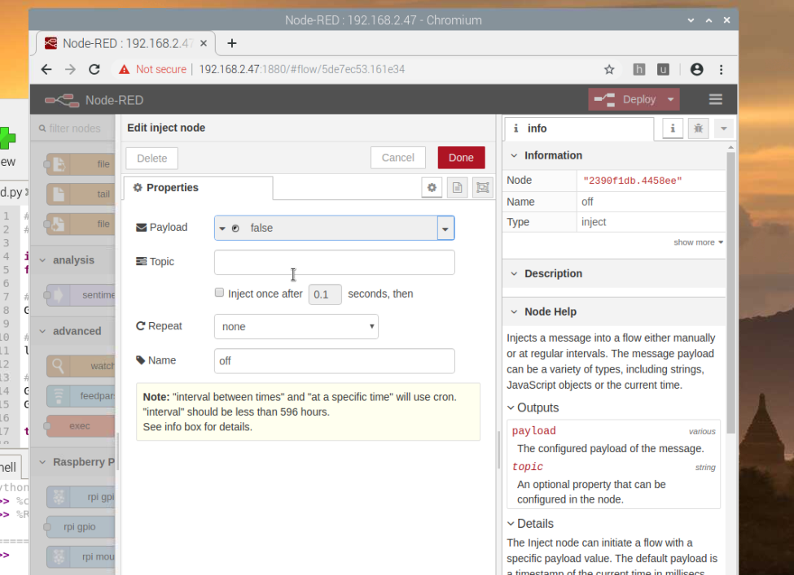

- Then Double click on the rpi gpio out and select the 15 pin and click on done.
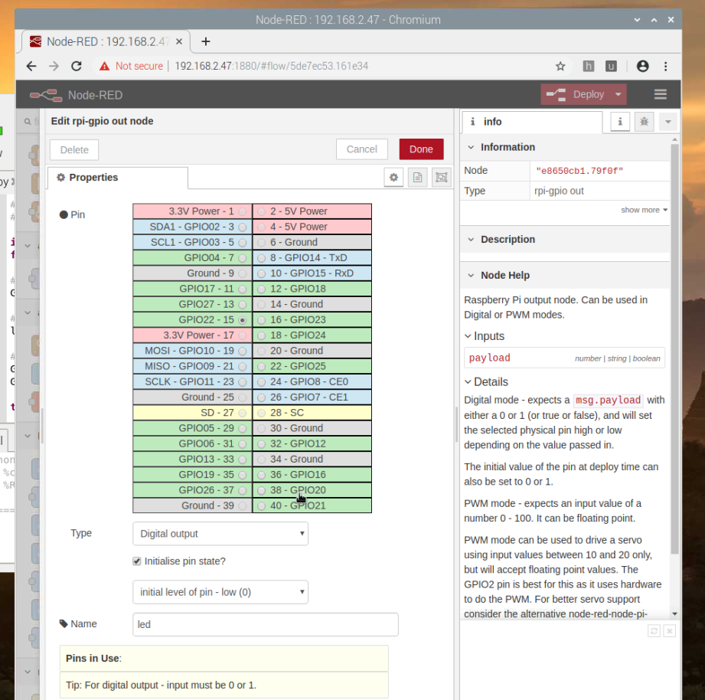
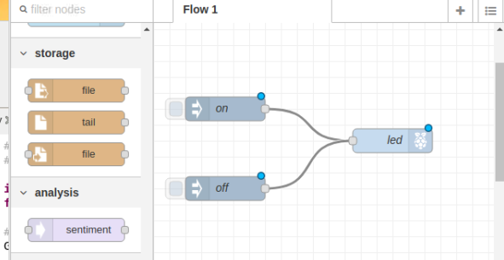

- Then Click on the Deploy if options given choose Full Deploy
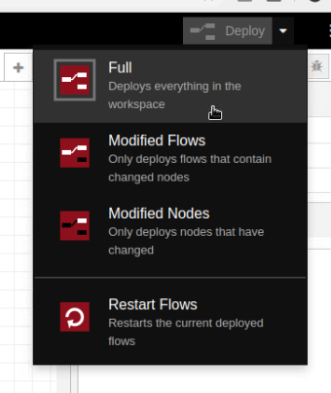

Output: -
